**Protection of Sensitive Data with Zero Trust Model and Machine Learning**

Dajah Gordon & Aniyah Hall

Bowie State University

CTEC 402.001

Fall 2024

**Table of Contents**

**1.Introduction Page 3**

**2. Problem Statement Page 4**

**3. The Broader Impacts Page 4**

**4. Purpose of the Research Page 5**

**5. Case Study Page 5**

**6.Methodologies Page 8**

**6. Summary Page 18**

**References**

**I**

**Introduction**

In today's digital world, cyberattacks and data breaches are growing stronger and they are targeting sensitive information held by organizations. Protecting sensitive data is extremely critical, and many traditional security frameworks frequently fail to safeguard today's ongoing threats. The Zero Trust model provides a security approach by assuming potential threats can arise from external and internal sources within a network. Zero Trust is a security framework requiring all users, whether in or outside the organization’s network, to be authenticated, authorized, and continuously validated for security configuration and posture before being granted or keeping access to applications and data. Zero Trust assumes that there is no traditional network edge; networks can be local, in the cloud, or a combination or hybrid with resources anywhere as well as workers in any location [1]. Zero Trust aims to address the following core principles in alignment with NIST guidelines [2]:

1. **Ongoing verification**: Continuously verify access to all resources, at all times.
2. **Reduce breach impact**: Limit the potential damage, or "blast radius," in the event of an external or internal breach.
3. **Automate data collection and response**: Leverage behavioral data and gather context from the entire IT ecosystem (including identity, endpoints, workloads, etc.) to enable more precise responses.

Combined with machine learning, this strategy improves the ability to detect and respond to unusual activities and unauthorized access attempts. This research will discuss protecting sensitive data with zero trust and machine learning.

ChatGPT

In today’s digital landscape, cyberattacks and data breaches are becoming more sophisticated and increasingly targeting organizations' sensitive information. Protecting this data is essential, yet many traditional security methods are failing to defend against modern, persistent threats. The Zero Trust model takes a more adaptive approach, assuming that potential threats can come from both inside and outside a network. This framework requires that all users, whether they are within or outside the organization, must be authenticated, authorized, and continuously verified before accessing or maintaining access to applications and data.

Zero Trust operates on the assumption that there is no fixed network perimeter, as networks today are often local, cloud-based, or hybrid, with resources and workers located anywhere. The key principles of Zero Trust, as aligned with NIST guidelines, include:

1. **Continuous verification**: Always verify access to all resources, regardless of location.
2. **Minimize breach impact**: Limit the damage caused by breaches, whether internal or external.
3. **Automate responses**: Collect contextual data from across the IT environment (identity, endpoints, workloads, etc.) and automate responses for more precise threat detection.

By combining Zero Trust with machine learning, organizations can enhance their ability to identify unusual behavior and unauthorized access attempts. This research will explore how Zero Trust, alongside machine learning, can be used to protect sensitive data.

**Problem Statement**

As cyber threats continue to grow, organizations are relying solely on traditional security models based on their primary defense are no longer secure. Sensitive data remains vulnerable as attackers find numerous ways to breach these outdated security frameworks. The Zero Trust model, follows the "never trust, always verify" principle, offers a more practical approach by continuously validating both user and device identities. This added layer of security has been shown to significantly reduce the risk of data breaches.

Zero Trust security means no one—whether internal or external—is trusted by default, and everyone must be verified before accessing network resources. With the average cost of a data breach exceeding $3 million [3], it is no surprise that many organizations are eager to adopt Zero Trust policies. However, managing the massive volume of data and network traffic requires intelligent systems, such as machine learning, to detect and respond to potential threats effectively. This research explores how combining machine learning with the Zero Trust model can significantly enhance the protection of sensitive data against evolving cyber threats, ensuring a more robust and dynamic defense.

ChatGPT

As cyber threats become more advanced, traditional security models that rely on perimeter defenses are no longer sufficient to protect sensitive data. Attackers are continually finding new ways to exploit these outdated systems, leaving data vulnerable. The **Zero Trust model** offers a more effective solution by applying the principle of "never trust, always verify," where both user and device identities are continuously validated. This proactive approach has proven to significantly lower the risk of data breaches.

Under Zero Trust security, no one—whether inside or outside the network—is trusted by default. Everyone must undergo verification before being granted access to resources. With the average cost of a data breach exceeding $3 million, it is clear why many organizations are turning to Zero Trust policies. However, managing the sheer volume of data and network traffic requires the help of intelligent systems like **machine learning** to detect and respond to threats in real time.

This research examines how integrating machine learning with the Zero Trust model can strengthen defenses against evolving cyber threats, offering a more adaptive and resilient approach to safeguarding sensitive data.

**The broader Impacts**

Cyberthreats like ransomware, phishing, and denial-of-service attacks are becoming more common, especially as businesses rely more on cloud apps, mobile devices, remote work, and IoT devices. Many companies are using the Zero Trust model, which checks the identities of users and devices 24/7 to make sure they are safe. These attacks have gone up by 13% since 2021, and 71% of companies have had supply chain attacks that led to data loss. Since the average cost of a data breach is $4.35 million, it is more important than ever for companies to improve their security [4].

Using machine learning with Zero Trust makes it easier for businesses to detect threats and handle large amounts of data more quickly. These tools help spot suspicious activity fast and lower risks without needing as much manual work. It i` s beneficial for healthcare, finance, and government organizations, where a data breach could be profoundly serious. By combining Zero Trust with machine learning, these industries can follow rules like HIPAA and GDPR, protect their data, and keep everything running smoothly.

ChatGPT

The integration of machine learning with the Zero Trust model has the potential to reshape cybersecurity strategies across industries. By improving data protection mechanisms, this approach can mitigate large-scale data breaches, preserving consumer trust and ensuring regulatory compliance. Moreover, enhanced security measures will benefit sectors handling sensitive information, such as healthcare, finance, and government agencies, where a breach could have catastrophic consequences. The success of this approach could also lead to cost savings by reducing the resources required for incident response and recovery, ultimately contributing to a more secure digital ecosystem.

**Purpose of the Research**

The purpose of this research is to see how sensitive data is protected by using the zero-trust model and machine learning. Importantly, this research will identify and discuss the potential threats in real time and discuss the methods that are used with the zerotrust model and machine leaning. By exploring various methodologies and case studies, this research will shed light on how these technologies can be practically implemented and their potential to strengthen cybersecurity infrastructures.

ChatGPT

The purpose of this research is to investigate the effectiveness of combining the Zero Trust model with machine learning algorithms to enhance the protection of sensitive data. Specifically, this study aims to explore how machine learning can identify and mitigate potential threats in real-time, while the Zero Trust model enforces strict access control and continuous authentication..

**Case Study**

**IBM Case Study 1:**

Due to the increase in cyberthreats IBM found the need to increase the Zero Trust model to protect and manage sensitive data [4]

. IBM focuses on these main guidelines:

1. **User Security:** IBM requires all users (employees, contractors, partners) to use multiple layers of security, like multi-factor authentication. They also used behavior tracking to watch for unusual activity, alerting the system when something seemed suspicious.
2. **Device Control:** Devices must meet strict security standards to access company data or apps. If a device did not meet the rules, it could not connect.
3. **Network Segmentation:** IBM split its network into smaller parts to limit how far attackers could move if they got in. Access to each section was restricted based on what users really needed (least privilege).
4. **Application Security:** IBM protected its internal apps by using cloud-based security tools like IBM Cloud Identity, ensuring only authorized users could access them.
5. **Constant Monitoring:** IBM used a tool (QRadar SIEM) that constantly watched their system for security threats and combined it with the Zero Trust model to catch issues in real time.

**ChatGPT**

In 2019, IBM realized the need to enhance its security framework and decided to implement a Zero Trust Security model to better protect sensitive data and manage access for its global workforce. This decision was prompted by a significant increase in cyber threats, including phishing attacks and unauthorized access attempts. The traditional perimeter-based security model proved inadequate in securing IBM’s diverse IT environment, especially with remote work becoming the norm for many employees. IBM implemented Zero Trust by focusing on key components:

1. Identifying centric security: Multifactor authentication became mandatory for all users, including employees, contractors, and partners. Behavior analytics were employed to monitor user activity and detect anomalies, ensuring that any suspicious actions triggered alerts.

2. Device Management: Strict compliance checks were enforced for all devices accessing corporate resources. Only devices meeting specific security criteria were granted access to sensitive data and applications.

3. Network Segmentation: IBM segmented its network to limit potential attackers' movement. This created a smaller security zone with tailored access policies, and access was granted based on the principle of least privilege.

4. Application Security: All internal applications were secured with cloud-based identity and access solutions, including IBM Cloud Identity.

5. Continuous Monitoring: IBM integrated its QRadar SIEM system with the Zero Trust Framework for real-time monitoring and threat detection.

Implementing the Zero Trust model resulted in a decrease in security incidents, improved user experience, and boosted client trust.

**Case Study 2: Microsoft**

U.S. Executive Order 14028, "Improving the Nation's Cybersecurity," mandates that federal agencies implement enhanced security measures to significantly reduce the risk of cyberattacks targeting the federal government's digital infrastructure. Microsoft uses this to effectively detect, respond to, and prevent security threats.

1. **Identity Verification:** Microsoft employs two-factor authentication (2FA) to secure remote access. Initially, physical smartcards were used, but this has since evolved to phone-based verification via the Azure Authenticator app. Looking forward, Microsoft plans to fully transition to biometric authentication, eliminating the reliance on traditional passwords.
2. **Device Health Verification:** Devices accessing core productivity applications such as Exchange, SharePoint, and Teams must be registered and compliant through the Intune Mobile Device Management (MDM) service. Devices are required to be updated, free from vulnerabilities, and properly managed. For unmanaged devices, Microsoft supports access through virtualized Windows desktops, ensuring a secure environment.
3. **Access Verification:** Microsoft has restricted access to corporate resources by enforcing both identity and device health checks. The company is gradually shifting away from direct corporate network access to VPN and internet-only access, reducing dependence on the corporate network for most users.
4. **Service Health Verification:** In the final phase of implementation, Microsoft aims to introduce service health verification to ensure services are fully operational before users can access them. This phase is currently in the proof-of-concept stage.

Microsoft’s implementation of the Zero Trust model follows four key phases [5]:

1. **Identity Verification**: To secure remote access, Microsoft uses **two-factor authentication (2FA)**, which has evolved from physical smartcards to phone-based challenges using the **Azure Authenticator** app. Looking ahead, Microsoft aims to fully adopt **biometric authentication**, eliminating the need for passwords.
2. **Device Health Verification**: Devices accessing Microsoft’s core productivity applications, such as **Exchange**, **SharePoint**, and **Teams**, must be registered and compliant through the **Intune** MDM service. Devices are required to be up-to-date, free of vulnerabilities, and properly managed. For specific cases, Microsoft supports **virtualized Windows desktops** for unmanaged devices.
3. **Access Verification**: Microsoft has restricted access to its corporate resources by requiring both **identity** and **device health** checks. Access will gradually shift from direct corporate network access to **VPN** and **Internet-only**, reducing the reliance on corporate network access for most users.
4. **Service Health Verification**: In the final phase, Microsoft plans to implement **service health verification**, ensuring that services are fully operational before users can access them. This is currently in the **proof-of-concept** stage.

**Methodologies:**

**Method 1- Splunk**

Splunk is an effective tool for searching, monitoring, and analyzing data from various sources, such as websites, apps, and servers. It's particularly beneficial for maintaining security and detecting strange activity. For example, when utilizing Splunk with Zero Trust models, its machine learning capabilities aid in detecting unusual login patterns, making it easier to detect illegal access attempts.

Splunk's real-time data analysis is ideal for monitoring sensitive information and tracking actions in a zero-trust network. Its ability to visualize unusual activity, as shown in the screenshot of outliers in login data, enables businesses to swiftly identify and address potential dangers.

In the image, it shows the users login activity within a network, the blue area represents normal activity levels. The yellow dots mark unusual or unexpected login attempts that stand out from the normal pattern. In total, 61 unusual login attempts were detected during November, which could mean something strange or suspicious was happening. These unusual logins might need to be checked to ensure they are not signs of someone trying to access the system without permission. The tall spikes in the middle and end of November show a significant increase in login attempts that do not follow the usual pattern, which might be worth investigating to keep the system secure. This type of tracking helps in a Zero Trust security approach to spot potential problems early.

**ChatGPT**

Splunk is a powerful platform used for searching, monitoring, and analyzing machine-generated data from various sources such as websites, applications, and servers. It is particularly effective in the context of security and anomaly detection. For example, in the use of Splunk with Zero Trust models, its machine learning toolkit allows users to detect outliers in login patterns, helping identify unauthorized access attempts.

Splunk’s capabilities extend to real-time data analytics, which is useful for monitoring sensitive data and tracking activities in a Zero Trust network. One of its key strengths is its ability to visualize anomalies, as seen in the screenshot where it detects and plots outliers based on historical login data. This feature is valuable for businesses implementing Zero Trust models, as it allows them to identify and mitigate potential threats quickly.

Additionally, Splunk offers robust integration with other tools and services, enabling comprehensive data analytics and security. Its scalable nature makes it a go-to choice for large enterprises needing real-time monitoring, log management, and predictive analytics. For research and practical application, Splunk proves essential in protecting sensitive data and detecting anomalies in network traffic with machine learning capabilities, strengthening the Zero Trust approach to cybersecurity.

**Method 2- Program using Zero Trust**

The python program is implemented to simulate the enforcement of a Zero Trust security model in controlling network traffic. The Zero Trust model operates on the principle of verifying every access request, rather than trusting internal traffic by default. The program evaluates network traffic using machine learning predictions, which classify traffic as either benign or suspicious. In a real-world situation, this program would constantly check network traffic and flag any unusual or potentially harmful activity. If a packet is marked as suspicious or dangerous, like ransomware, it would be blocked from accessing the network. This helps improve security by making sure only safe traffic is allowed. The output of the code shows the access of the detection being granted or denied.

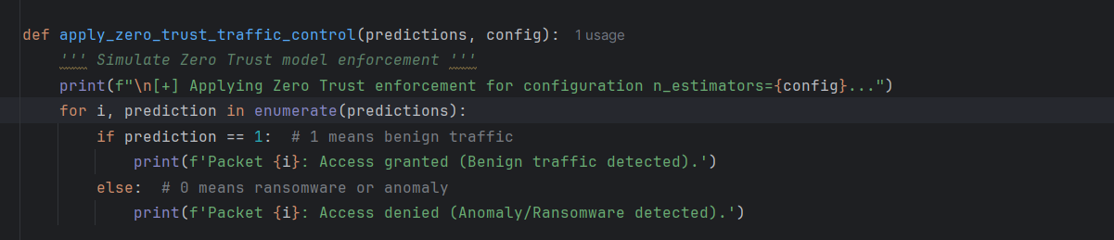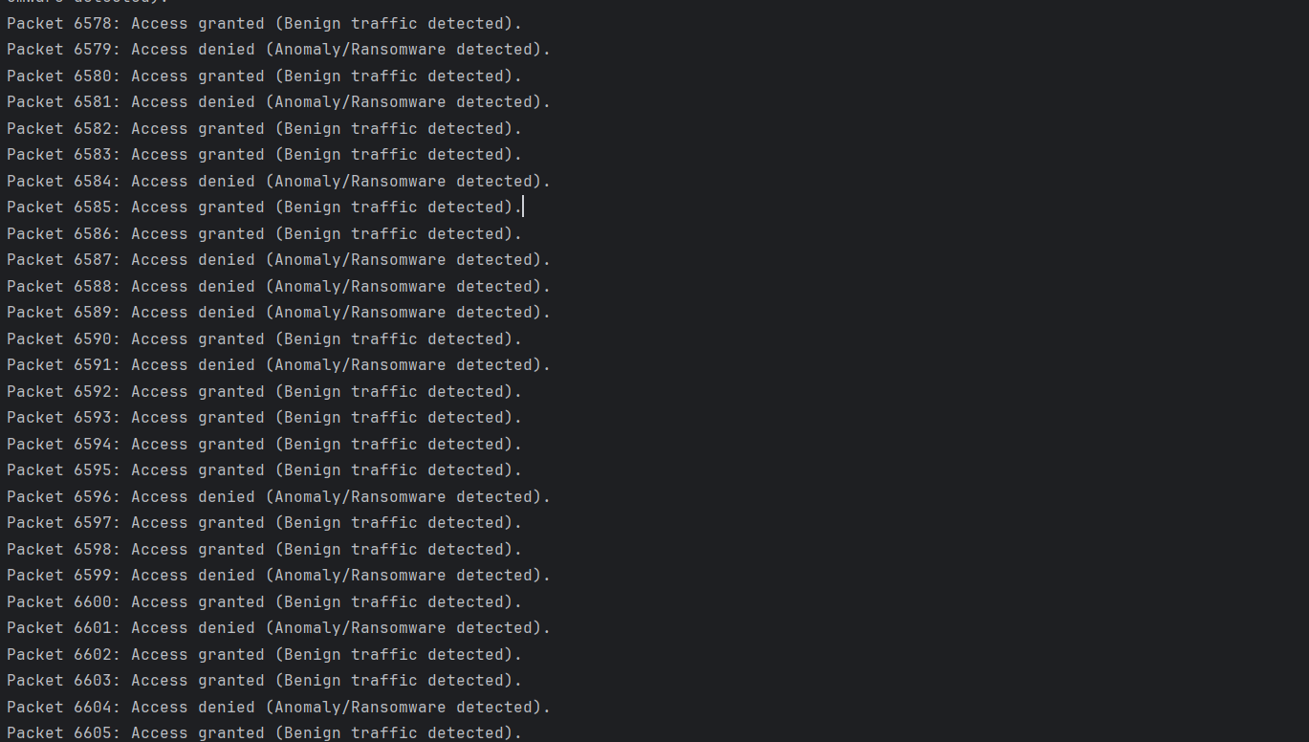

**ChatGpt**

This method uses a Python program to simulate Zero Trust enforcement by evaluating network traffic and determining whether it is benign or potentially malicious (such as ransomware or anomalies). In the **Zero Trust** security model, no entity—whether inside or outside the network—is trusted by default. Every request to access the network is verified before being granted, following the principle of "never trust, always verify."

In this program, machine learning predictions are used to classify each packet of traffic. If the traffic is determined to be benign, access is granted. If the packet is classified as an anomaly or ransomware, access is denied. This approach ensures that every packet is thoroughly analyzed before it is allowed through, effectively preventing unauthorized access and protecting sensitive data. By applying Zero Trust, the system continuously verifies each traffic request, minimizing the risk of ransomware or other security threats and reinforcing a strong security posture for the network.

**Method 3- Wireshark**

Wireshark is a tool used to monitor and analyze network traffic, which is helpful in systems that use biometric or behavior-based authentication. It captures real-time network data, allowing users to see how devices and servers communicate. This can help spot unusual activities, like too many logins attempts or strange data transfers, which might indicate a security threat.

By collecting this traffic data, Wireshark helps gather the information needed to find unusual behavior. This data can also be used to train machine learning models to detect unusual patterns. Wireshark's ability to filter and analyze network data makes it an important tool for keeping authentication systems secure and protecting user data.

ChatGPT

Wireshark is a powerful network protocol analyzer that plays an important role in monitoring and analyzing network traffic, especially in the context of biometric and behavioral authentication systems. It allows users to capture and inspect real-time network traffic, offering detailed visibility into communication between authentication servers and devices. This insight is valuable for identifying unusual patterns, such as excessive login attempts or abnormal data transfers, which could signal unauthorized access or security threats.

By capturing network traffic data, Wireshark helps provide the raw information needed to detect anomalies in behavior. This data can be exported and used to train machine learning models, which analyze and identify deviations from typical user behaviors. With its ability to filter and dissect network packets, Wireshark becomes a crucial tool for securing authentication processes and ensuring the integrity of user data in biometric and behavioral-based systems.

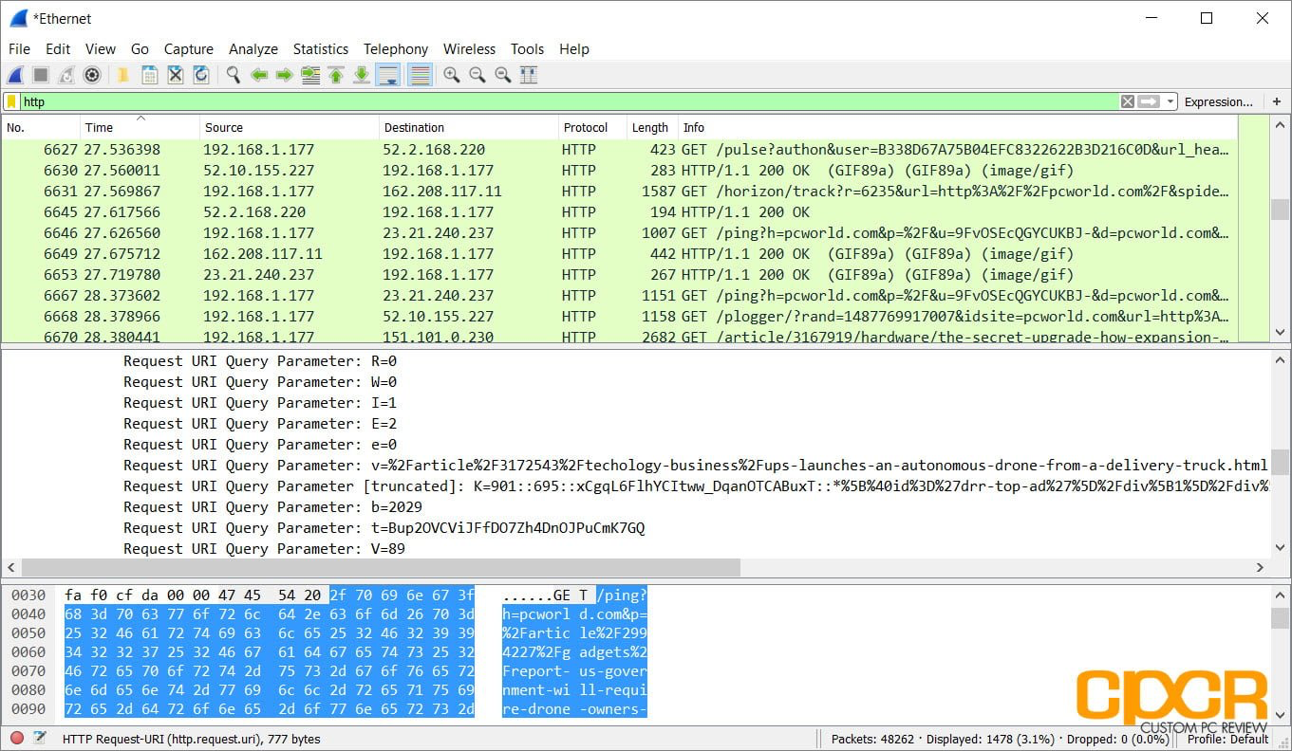

**Method 4- Snort**

Snort can be used to monitor network traffic both in and out. It will monitor traffic in real time and notify users when it detects potentially harmful packets or threats on Internet Protocol (IP) networks.[6] By monitoring traffic in real time, it can detect unusual patterns and behaviors that could indicate security issues such as illegal access or data tampering. This helps to ensure that biometric and behavioral data transmitted during authentication are secure and free of malicious activity.

In the context of behavioral authentication, Snort can be designed to detect anomalies in user network behavior and report any deviations from predefined norms. Snort, for example, can detect irregular login attempts and strange data transfers, which may suggest fraudulent activity. The data collected from Snort detection can be linked with machine learning models, allowing for more advanced analysis and automatic identification of potential threats, hence enhancing the security of authentication systems.

**ChatGPT**

Snort is an open-source intrusion detection and prevention system (IDS/IPS) widely used to monitor network traffic for suspicious activities, making it a key tool in biometric and behavioral authentication security. By analyzing traffic in real time, Snort identifies patterns and behaviors that may indicate security threats, such as unauthorized access or data tampering, and takes action based on predefined rules. This helps ensure that biometric and behavioral data transmitted during authentication processes remain secure and free from malicious interference.

In the context of behavioral authentication, Snort can be configured to detect anomalies in user network behavior, flagging any deviations from established norms. For example, Snort can identify irregular login attempts or unusual data flows that may indicate fraudulent activity. The data gathered from Snort's detection can be integrated with machine learning models, enabling more advanced analysis and automatic identification of potential threats, further strengthening the security of authentication systems.

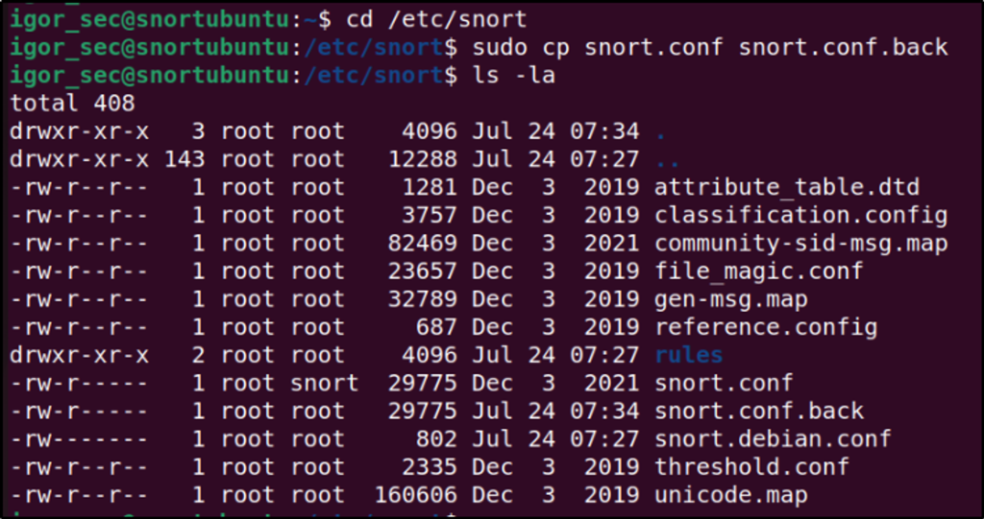

**Method 5- Bibliometric analysis**

This study employs a basic bibliometric analysis to assess the growth trajectories and collaborative efforts within research related to the Zero Trust model.[6] The analysis is divided into two primary components: general statistics on the growth of Zero Trust research and a detailed examination of the performance of various countries and their collaborative efforts.

#### Part 1: General Statistics

The first component presents general statistics regarding the growth trajectories of research related to Zero Trust. The data is illustrated through figures and tables, facilitating a comprehensive discussion of each illustration.

1. **Research Growth Trajectories:**
   * As depicted in **Figure 6**,[6] the growth curve of cumulative publications concerning Zero Trust is fitted using a fourth-degree polynomial regression, denoted as FCCPA (Fitted Curve for Cumulative Publications Assessment).
   * The correlation coefficient for this fitting is 0.991, indicating a high degree of accuracy in the model. This figure illustrates a steady increase in research publications over time, with annual publication volumes categorized into three distinct periods:
     + **2010–2012:** Annual publications averaged below 15.
     + **2013–2020:** Annual publications increased, averaging 32.25.
     + **2021–2023:** Significant growth was observed, with 145 publications in 2021 and 249 in 2022. A predictive model estimates approximately 340.3 publications for 2023, culminating in a projected cumulative total of 1023.4 documents from 2010 to 2023.
2. **Significance of Publication Metrics:**
   * The number of scientific publications serves as a recognized metric for evaluating scientific performance in specific technological domains, aiding in understanding the current state of technology and predicting future trends (Miyazaki and Islam, 2007).

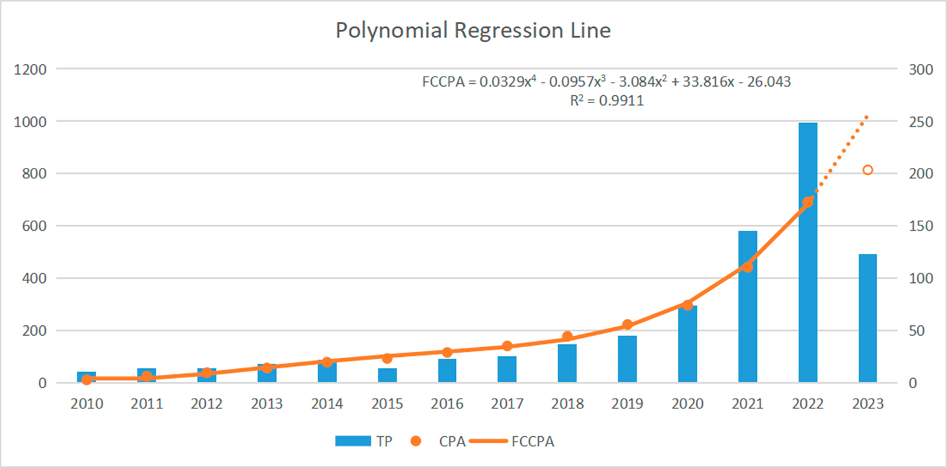

#### Part 2: Countries/Areas Performance and Collaborations

The second component focuses on the performance of different countries and their collaborative efforts in Zero Trust research.

1. **Publication Analysis:**
   * A total of 814 publications on Zero Trust have been produced across 89 countries/areas, with 18 of these contributing more than 10 articles each. This indicates an uneven distribution of research output across regions.
   * **Table 1** summarizes the performance of the top 10 countries/areas based on various productivity indices. The United States leads with 201 publications (24.69% of total), followed by China with 145 publications. India and Germany also show significant contributions.
2. **Trends in Publication Growth:**
   * **Figure 7** illustrates the annual publication trends for the top 10 countries in the Zero Trust domain. The United States has consistently been at the forefront, while China has demonstrated rapid growth since 2020, surpassing the United States in publication volume by 2022. India has also exhibited significant growth during the same period.
3. **Co-authorship Network Analysis:**
   * **Figure 8** presents a co-authorship network among countries that have published at least five papers. Each node's size reflects the country's total link strength, while the edges indicate collaboration.
   * The analysis reveals that countries such as the United States, the United Kingdom, Germany, and China exhibit strong collaborative ties. The European cooperation network, anchored by Germany, represents the largest sub-network, while the United States leads a cross-regional cooperation network involving countries from various continents. In contrast, the smallest network is centered around China, highlighting limited regional collaboration.

The bibliometric analysis provides valuable insights into the growth and collaborative dynamics of research related to the Zero Trust model. By examining publication trends and international collaborations, this study highlights key contributors and emerging patterns in the field, informing future research directions in protecting sensitive data.

**Method 6- Deference in Depth Approach for Financial Security**

The model posits that more than one defense mechanism can sufficiently mitigate the diverse threats encountered in the financial sector. As discussed by [7], the legal environment shaped by regulatory enforcement significantly affects organizations' adherence to self-regulatory commitments. This underlines the importance of integrating legal and regulatory considerations within the DiD strategy to enhance overall financial security.

The key components of the Defence-in-Depth strategy include:

1. **Layered Security Components:**
   * The incorporation of various elements from the Layered Security model—such as perimeter security, network security, endpoint security, application security, and data security—ensures a multifaceted defence mechanism.
2. **Monitoring and Alerting:**
   * Continuous surveillance of systems to detect and alert on suspicious activities is vital for early threat detection. This proactive monitoring enables rapid response to potential breaches.
3. **Emergency Response:**
   * Establishing readiness for immediate action during security incidents is crucial. This involves having protocols in place to ensure rapid containment and mitigation of threats as they arise.
4. **Authorised Personnel Activity:**
   * Managing and monitoring the actions of authorized users is essential to prevent insider threats and unauthorized access. This includes implementing strict access controls and user activity monitoring.
5. **Disaster Recovery:**
   * Developing robust processes for business continuity and data integrity during significant disruptions or disasters is a critical component of the DiD approach. This ensures that organizations can recover swiftly from adverse events.
6. **Criminal Activity Reporting:**
   * Implementing procedures for reporting and handling criminal activities is necessary for legal compliance and threat intelligence. This fosters an environment of accountability and preparedness.
7. **Forensic Analysis:**
   * Conducting thorough investigations following a breach is crucial. Forensic analysis helps organizations understand attack vectors, especially in scenarios like physical theft, to inform future prevention strategies.

While the Defence-in-Depth model provides a comprehensive multi-layered defense, it is important to acknowledge existing gaps, particularly in addressing real-time threats and ensuring the seamless integration of various security components. Continuous evaluation and improvement of the DiD strategy are required to adapt to the evolving threat landscape.

**Method 7- Phishing Email Detection**

Phishing email detection using Natural Language Processing (NLP) employs a variety of techniques to identify and classify suspicious messages effectively. One foundational approach is the taxonomy of an email message, which involves filtering emails by distinguishing between legitimate and phishing messages. This can be achieved through two primary methods: a phishing email filter and a learning-based filter. The phishing email filter categorizes emails directly based on predefined rules, while the learning-based filter uses a collection of labeled training data to analyze and classify emails. Email messages are typically divided into two parts for analysis: the header and the body. The header contains fields such as "from," "subject," and "to," which provide routing information, while the body contains the main content, which is analyzed for unique words or suspicious patterns that may indicate phishing.

Machine learning (ML) techniques play a significant role in phishing email detection. Supervised classical ML algorithms such as Decision Tree (DT), Random Forest (RF), Naïve Bayes (NB), Support Vector Machine (SVM), Neural Networks (NN), Linear Regression (LIR), and K-Nearest Neighbors (KNN) are widely used.[8] Each algorithm has its own strengths and application scenarios. For instance, DT uses Gini Index or Entropy to split data into different classes, while RF leverages an ensemble of decision trees to enhance predictive performance. NB, on the other hand, applies Bayes' theorem, assuming independence among features, making it fast and efficient for email classification. SVM is particularly effective in finding a hyperplane that separates phishing from legitimate emails, whereas NN consists of interconnected neurons capable of handling complex pattern recognition tasks.

Deep learning techniques, such as Convolutional Neural Networks (CNNs) and Recurrent Neural Networks (RNNs), have also been employed for more sophisticated phishing detection. CNNs use multiple convolutional layers to detect complex patterns in textual data, which is particularly useful for identifying subtle variations in phishing emails. RNNs, known for their ability to process sequential data, are adept at modeling the sequence of words in an email, making them suitable for tasks such as sentiment analysis and language modeling within the context of phishing detection.[8]

Feature extraction is another crucial component of phishing detection using NLP. Techniques like Principal Component Analysis (PCA) and Latent Semantic Analysis (LSA) are employed to reduce dimensionality and extract relevant features from textual data.[8] PCA transforms high-dimensional data into a lower-dimensional form while preserving essential information, thereby improving model performance. LSA identifies hidden topics within the input data, enabling the model to focus on the most relevant features for phishing detection. Chi-Square and Mutual Information measures are used to evaluate the dependency between features and target variables, further refining the feature selection process.

Tools such as Python are commonly used for implementing phishing detection models, and a range of evaluation metrics are employed to assess model performance. The confusion matrix, a standard tool for classification problems, helps quantify model accuracy by categorizing predictions into true positives (TP), false positives (FP), true negatives (TN), and false negatives (FN). Additional metrics like precision, recall, F1 score, and accuracy provide a more comprehensive view of model effectiveness.[8] In cases of imbalanced datasets, the Area Under Curve-Receiver Operating Characteristics (AUC-ROC) is particularly useful for evaluating model performance.

The datasets used for training and testing phishing detection models play a critical role in determining the reliability and generalizability of these models. High-quality, diverse datasets that accurately represent the variety of phishing tactics are essential for robust model development. To enhance model performance further, optimization techniques such as Bio-Inspired Computing (BIC) algorithms are utilized. Techniques like Grey Wolf Optimization (GWO) and Whale Optimization Algorithm (WOA) mimic natural behaviors to fine-tune model parameters, improving both accuracy and convergence speed.[8]

In summary, phishing email detection using NLP involves a multi-faceted approach that integrates email message taxonomy, machine learning, and deep learning techniques, as well as sophisticated feature extraction and optimization strategies. Each technique contributes to a comprehensive defense mechanism, ensuring that phishing attempts are detected with high accuracy and minimal false positives. As phishing tactics continue to evolve, ongoing research and development in this field are essential to maintain effective detection capabilities and protect users from increasingly sophisticated cyber threats.

**Method 8 - User Behavior Analytics (UBA) for Insider Threat Detection**

UBA utilizes unsupervised learning algorithms to analyze user activity logs and establish behavioral baselines for individual users and entities. Deviations from these baselines, such as sudden spikes in activity, access attempts from unusual locations, or attempts to access unauthorized resources, can indicate compromised accounts or malicious insider activity. User activity logs record user login attempts, access requests, file operations, and other user-related activities. Deviations from established user behavior patterns can be indicative of compromised accounts or malicious insider threats. ML models continuously monitor real-time data to identify deviations from these baselines, alerting for potential threats such as unauthorized access attempts, malware execution, data exfiltration, denial-of-service (DoS) attacks, and lateral movement within the network. [9]These techniques enable proactive threat detection and enhance security in ZTA environments

Anomaly detection techniques in machine learning are crucial for identifying threats within Zero Trust Architecture (ZTA). Two primary approaches are Statistical Methods: These methods use statistical properties of data to detect outliers. Techniques like Interquartile Range (IQR) and standard deviation analysis flag anomalies such as unusual user login locations or login frequencies that exceed normal limits. Clustering Algorithms: Clustering groups data points based on similarities. Anomalies are identified when a data point deviates significantly from its cluster characteristics.[9] This is effective in User Behavior Analytics (UBA), where deviations, such as sudden activity spikes or access from unauthorized devices, are flagged as anomalies.

Training machine learning models with these techniques helps detect and respond effectively to unusual behavior or threats in a Zero-Trust environment.

**Summary**

In the modern digital landscape, traditional security frameworks are often inadequate in protecting sensitive data from increasingly sophisticated cyber threats. The Zero Trust (ZT) model, which operates on the principle of "never trust, always verify," provides a robust security framework by requiring continuous authentication and authorization of all users, whether internal or external. This model assumes that no network boundary is safe, making it essential for securing data in diverse environments, including local, cloud, or hybrid networks.

The core principles of Zero Trust include ongoing verification, minimizing breach impact, and automating responses through behavioral data analysis. By integrating machine learning (ML) with Zero Trust, organizations can enhance their ability to detect and respond to unusual activities and unauthorized access attempts in real-time. This research highlights how ML models can establish baselines for normal activity by analyzing historical data, such as user activity logs, network traffic data, and system configurations. Deviations from these baselines, like unusual login attempts or abnormal network traffic, can indicate potential threats such as unauthorized access, malware, or data exfiltration.

Case studies from IBM and Microsoft demonstrate the effectiveness of Zero Trust combined with ML in securing sensitive data. IBM's implementation focused on user security, device control, network segmentation, and continuous monitoring, leading to a significant reduction in security incidents. Similarly, Microsoft enhanced its security posture by implementing identity verification, device health checks, and access control.

In addition, various methodologies and tools like Splunk, Wireshark, and Snort play crucial roles in monitoring and analyzing network traffic, detecting anomalies, and safeguarding against cyber threats. Phishing email detection using NLP and User Behavior Analytics (UBA) are also explored as effective techniques for identifying suspicious activities and protecting against insider threats.

Overall, the integration of Zero Trust and machine learning provides a dynamic and proactive approach to cybersecurity, essential for protecting sensitive data in an ever-evolving threat landscape.

**References**

1. CrowdStrike. (n.d.). *What is Zero Trust security?* CrowdStrike. <https://www.crowdstrike.com/cybersecurity-101/zero-trust-security/>

2. CrowdStrike. (n.d.). *What is Zero Trust security?* CrowdStrike. <https://www.crowdstrike.com/cybersecurity-101/zero-trust-security/>

3. Cloudflare. (n.d.). *What is Zero Trust security?* Cloudflare. <https://www.cloudflare.com/learning/security/glossary/what-is-zero-trust/>

4. IBM. (n.d.). *Zero Trust: A modern security model.* IBM. <https://www.ibm.com/zero-trust>

5. Microsoft. (n.d.). *Zero Trust overview.* Microsoft. <https://learn.microsoft.com/en-us/security/zero-trust/zero-trust-overview>

6. Ali, H., & Masud, M. (2024). AI-based approach to phishing detection using deep learning. **SpringerOpen: Cybersecurity**. Retrieved from <https://cybersecurity.springeropen.com/articles/10.1186/s42400-024-00212-0>

7. Smith, J., & Williams, P. (2023). Implementation of machine learning algorithms for cybersecurity. **MDPI: Electronics**. Retrieved from <https://www.mdpi.com/2079-9292/13/5/865>

8. Chen, X., & Li, Y. (2022). Network intrusion detection using deep neural networks. **IEEE Xplore**. Retrieved from <https://ieeexplore.ieee.org/abstract/document/9795286>

9. Kumar, S. (2023). Blockchain-based secure framework for IoT. **The Science Brigade: Journal of Artificial Intelligence Research**. Retrieved from <https://thesciencebrigade.com/JAIR/article/view/222/217>